**Design Phase**

**Mock Ups**

**INVENTORY**

**-**All the book returned will monitor and save .

**BOOK RETURNED**

**-**Form for returned book

**MATRIALS**

-Registered books

**BORROWER**

-there is 2 types of borrower the student and teacher.

**BOOK BORROWED**

-This the form for the book which borrowed student of teacher.

**LOGOUT**

-back to the login form.

**MAIN FORM**

**LOGIN FORM**

-Only the librarian can open or access the system.

**BOOK LOANING SYSTEM**

**(**PLACER WEST CENTRAL ELEM. SCHOOL)

**UX Interface Design**

**LOGIN FORM**

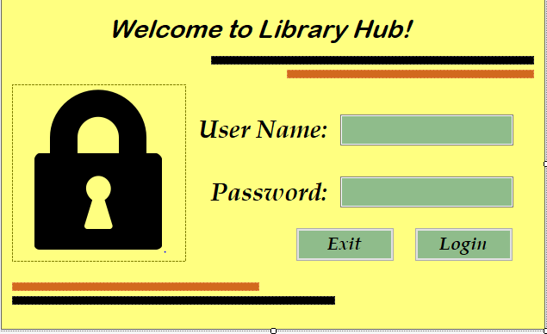

**MAINFORM**

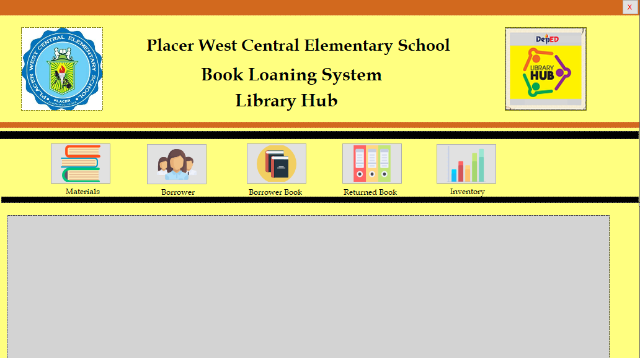

**Materials**

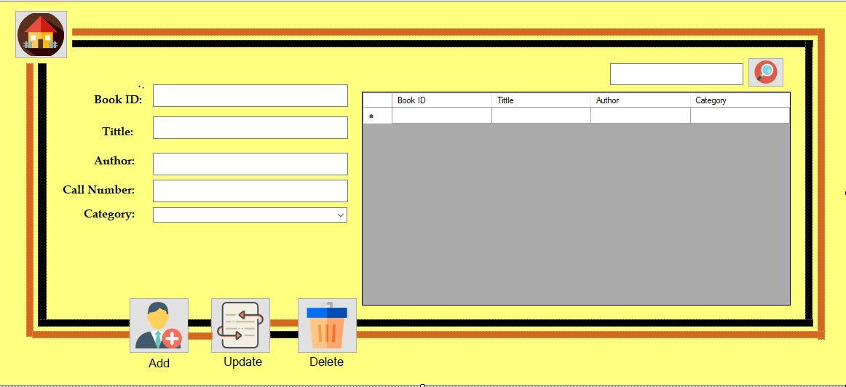

**Borrower**

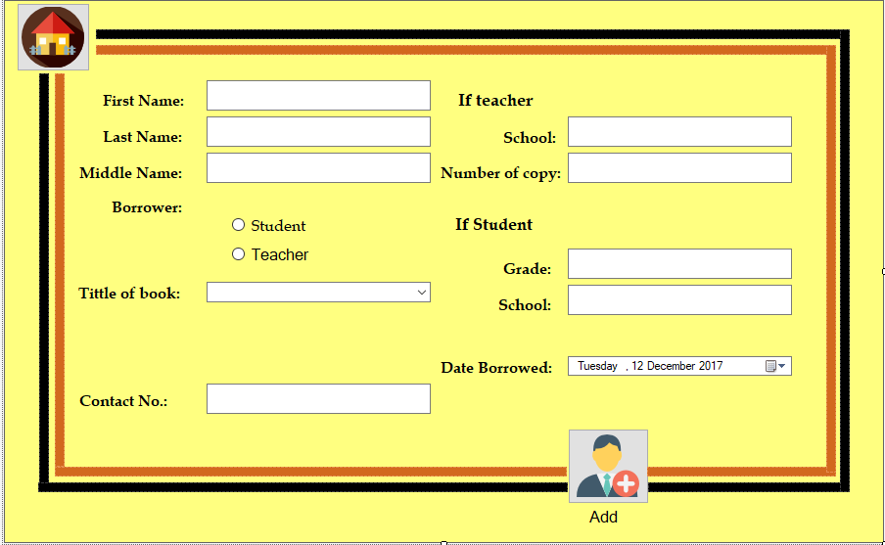

**Back End Design**

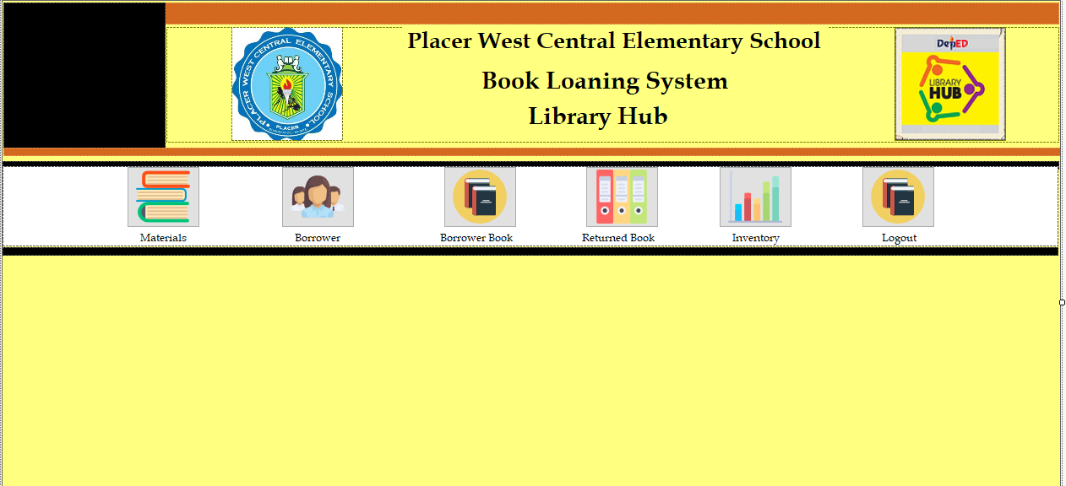

Back End Design